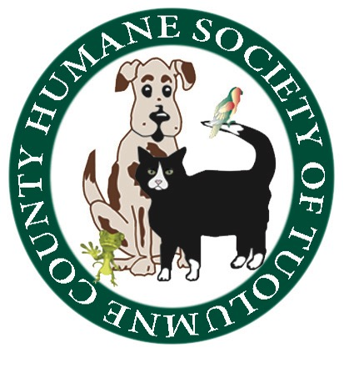
Humane Society of Tuolumne County
May 31, 2017 5:30 P.M., Shelter Conference Room

Board Members In Attendance: Jean McClymonds, Annette Tessaro, Claudia Heath, Doryene Rapini,
Barbara Miller, Marge Czadzeck, Mag Bergstrom

Board Members Absent: Mike Strange
Is there a quorum? Yes

PUBLIC BOARD OF DIRECTORS MEETING
Proceedings of the Meeting

CALL TO ORDER
The meeting was called to order at 5:30 P.M. by Vice President Marge Czadzeck

Review and Approval of minutes from April 26, 2017 Board meeting: Doryene Rapini moved to approve the minutes, Annette Tessaro seconded the motion.

Old Business/Updates: Financial report given by executive director Jean McClymonds. 30% profit split from the Champagne Brunch proceeds went to Spay and Neuter group. HSOTC was invited to work the Beer Booth for the Tuolumne County Fair July 7, 8, and 9, 2017. The Whiskers, Wags, and Wine event will be held Saturday September 23rd in the HSOTC Conference Room. Ayrael Vieux Winery and Chef Dave Cooks will be providing food appetizer and wine pairing. There will be a Mystery Box Raffle and a Cat/Dog Coin Toss for local winery gift basket. We are planning to have 54 seats for the event. February 17th, 2018 will be the date for Pawsta Pawty. There will be Mystery Boxes, dancing, with music by Mountain Sound. The 2018 Champagne Brunch will have a London-French theme, “Tails of Two Kitties” and the date will be April 29, 2018.

New Business:

Shelter Report –As of the beginning to the month, we started with 16 dogs and 12 cats. 6 dogs and 6 cats were adopted during the month.

Spay and Neuter Report – none

A/C Report- none

Vet Report – The topic of HSOTC and PetSmart partnering was discussed. Because HSOTC would be obligated to follow PetSmart protocols, such an arrangement was deemed undesirable.

CLOSED SESSION OF BOARD OF DIRECTORS MEETING: Estate donations were discussed.

The next Board Meeting is June 28, 2017

Respectfully submitted,

Claudia Heath

Claudia Heath, Board Secretary/Member

