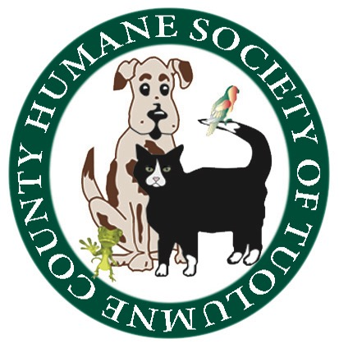
Humane Society of Tuolumne County
August 30, 2017 5:30 P.M., Shelter Conference Room

Board Members In Attendance: Jean McClymonds, Claudia Heath, Mike Strange, Annette Tessaro, Mag Bergstrom, Marge Czadzeck, Doryene Rapini

Board Members Absent: Barbara Miller
Is there a quorum? Yes

PUBLIC BOARD OF DIRECTORS MEETING

CALL TO ORDER
The meeting was called to order at 5:30 P.M. by Board President Mike Strange.

Review of Board Minutes from 7/26/2017 meeting: Motion to approve the minutes made by Annette Tessaro; motion seconded by Doryene Rapini.

Old Business/Updates: Financial report was given by Executive Director Jean McClymonds indicating a profit
from the crematorium proceeds, as well as the Spay and Neuter program. However, overall, financial statement indicated an approximate balance deficit of $4000.00.

On Saturday 9/23/2017, our fundraising event “Whiskers, Wags, and Wine” will be held in the HSOTC Conference Room from 3:30pm to 5:30pm. Ayrael Vieux Winery and Chef Dave Cooks will provide food appetizers and wine pairing. Additionally there will be our Mystery Box Raffle along with our Cat/Dog Coin Toss. We will also have a special prize Wine Basket including wines from Gianelli winery as well as a dessert wine from Ayrael Vieux.

It was noted that the Spay & Neuter Group has approximately $2000.00 in their account and the group may not participate in the Christmas Arts and Crafts Faire this year, as Bernadette has some health issues that will prevent her from organizing it.

Some discussion ensued regarding issues that have come up at the shelter with volunteers, as well as, staff.

Shelter Report : Brought in six dogs, three cats
Adopted six dogs and four cats

Spay and Neuter Report : No report

Animal Control Report: Overfilled and crowded.

Vet Report: No report as Barbara Miller in not in attendance at today’s meeting.

The meeting adjourned at 6:35 pm

The next Board Meeting will be Wednesday, September 27, 2017, at 5:30 pm in the Conference Room of the HSOTC.

Respectfully submitted,

Claudia Heath

Claudia Heath, Board Secretary/Treasurer

