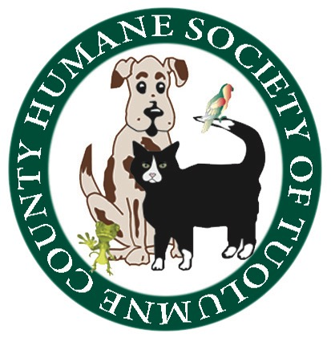
Humane Society of Tuolumne County
Board of Directors Meeting
Wednesday January 25, 2017 5:30 P.M., Shelter Conference Room

Board Members In Attendance: Jean McClymonds, Doryene Rapini, Claudia Heath
Board Members Absent: Mike Strange, Mag Bergstrom, Barbara Miller, Marge Czadzeck
Is there a quorum? No.

PUBLIC BOARD OF DIRECTORS MEETING:
Proceedings of the Meeting

Call to Order:
The meeting was called to order at 5:30 P.M. by Doryene Rapini

Old Business: Furever Dance scheduled for Friday February 10th, has sold 10 (ten) tickets at this point and we need to sell at least 35-40 to proceed with the event. Jean will be sending out a Constant Contact to encourage more ticket sales.

Interviews are currently underway with three candidates who have applied for the position of Event Planner and Volunteer Coordinator.

A “Celebration of Life “ memorial event will honor Ruth Olsen and is scheduled for , is scheduled for Saturday, January 28, 2017 at 11:00am in the HSOTC Conference Room.

Financials: Jean McClymonds announced that a recent bequest to HSOTC, along with our crematorium services, lead to a positive cash flow month.

Shelter Report: For the year 2016, the final count for the total number of adoptions of dogs and cats was revised from 306 animals to 253.

Spay/Neuter Report: None

Animal Control Report: Jennifer Clarke will be retiring March 15th, 2017.

The next HSOTC Board meeting is scheduled for Wednesday, February 22, 2017
The meeting adjourned at 6:15 P.M.

Respectfully submitted
Claudia Heath
Claudia Heath
Secretary, Board of Directors

